Why I’m Hopeful Regarding Climate Change
By Timothy Nash, Sustainable Economist and Ethical Markets Director of Sustainability Research
www.sustainableeconomist.com
On September 21, 2014, I joined more than 400,000 people in New York City for the People’s Climate March. It was a remarkable experience. Marching was great, but the best was stopping to watch the stream of people pass by. It was so inspiring to see so many different people, from so many different places. Although each person had their own reasons for showing up, we were united in a clear voice for climate justice.
Lingering from the experience is a strong sense of hope. Hope that there will be enough leaders in time. Hope that we will avoid the worst case scenarios of climate catastrophe. Hope that an economic transition is coming. Here’s why I’m optimistic:
The March
I’ve never seen so many ‘Tax Carbon’ signs in my life. It was a Sustainable Economist’s dream! If you’re curious at all about the march itself, here’s a great video from Rolling Stone. The most amazing moment of the day was the minute of silence, followed by a giant wave of beautiful noise. That so many people showed up is a clear indication that this issue is growing a bigger tent. It was amazing to see so many different groups participating including labour, indigenous communities, poverty advocates, students, and grandparents. Climate change is no longer just an environmental issue. People are connecting the dots between the society, the environment, and the economy.
Divestment
When the Rockefeller Foundation made the announcement to divest their holdings from fossil fuels, it sent a strong message of ‘out with the old, in with the new’. The divestment campaign has been growing strongly - now with more than $50 billion in assets - but it’s the more symbolic gestures that seem to capture the mainstream media’s attention. Rockefeller’s fortune originally came from Standard Oil, so the fact that heirs of this wealth are deciding to divest is significant. It suggests a great opportunity when it comes to the intergenerational transfer of wealth that is currently taking place at an unprecedented scale. As young people inherit their parents’ & grandparents’ wealth, it presents a wonderful opportunity to examine just how that money is being invested.
Green Investment
In addition to the divestment movement, we’re also seeing a surge of investments in green infrastructure projects. The latest Green Transition Scoreboard report details more than $5.7 trillion in private investments since 2007 into green sectors like renewable energy, green construction, and water infrastructure.
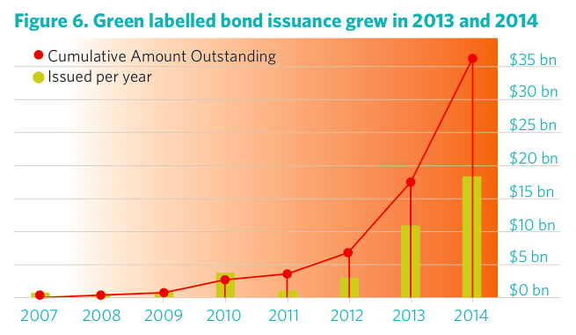
We’ve seen an explosion of green bonds issued in 2013 and 2014 (image above). According to ClimateBonds.net, most of these bonds have been oversubscribed, suggesting strong demand from institutional investors that are actively looking to ‘green’ their portfolio. The economic argument for shifting away from fossil fuels into low-carbon companies and projects has never been stronger. Below is the three-year chart comparing the iShares Oil Sands Index ETF (orange line) to the First Trust NASDAQ Clean Edge Green Energy Index Fund (green line). Investments in the tar sands have been stagnant due to low prices and pipeline protests, while investments in green energy have doubled in the past year.
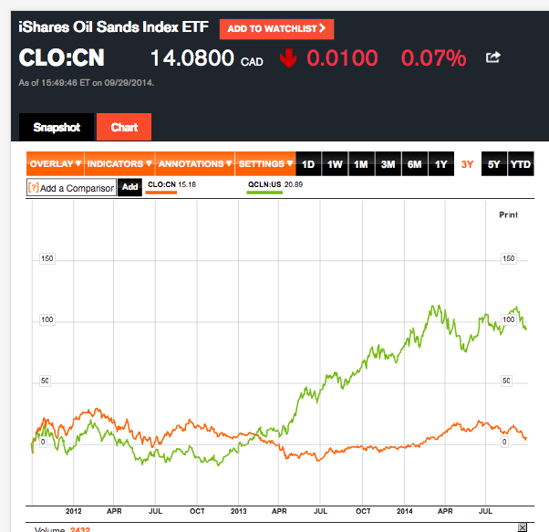
Political Leadership
As per usual, it seems that grassroots activists and economic indicators are out in front of political leadership. But we’ll need all hands on deck in order to avoid the worst case climate scenario. Putting a price on carbon is a crucial signal for the market to appropriately respond to the climate crisis. Without it, the green economy will be fighting an uphill battle. So as much as I’ll tie my hope to grassroots activists and intelligent investors, I know that the December 2015 meeting in Paris will be an important moment in human history. My hope is that we’ll have a new Canadian federal government by then. And I’m optimistic that world leaders can put their differences behind them, and move forward together with a common vision for the future of our species.
Conclusion
There is a new spirit in the climate change movement. Farmers, scientists, aboriginal leaders, economists, social justice activists all standing shoulder-to-shoulder in solidarity. When has a campaign ever brought together such diverse groups? I can’t say for certain that we’re going to change the course of humanity’s relationship with our planet, but I’m feeling hopeful that this challenge is uniting us as a species like nothing else before.
Read on SustainableEconomist.com blog

